**Step 1: Prepare softcopies of the following documents on your computer.**

1. Either softcopy of IC (front and back) or use your SingPass (Mandatory)

2. Highest education Level Certificate and Transcript (Mandatory)

3. CV (Mandatory)

4. Any other supporting documents (Optional)

**Step 2: Create a new User Account on the Online Application Portal.**

1. Go to the <https://myapplications.nus.edu.sg/psc/cssoas/EMPLOYEE/SA/c/N_APPLICATIONS_SELF_SERVICE.N_APP_LOG_AUTH.GBL?Page=N_APP_LOG_AUTH&Action=U>

2. Click on “Register New User Account”

3. Complete the details and create a new user account.

4. **Note**: Use an email account that has access to the Internet

**Step 3: Login to the Online Application Portal.**

1. Go to [**https://myapplications.nus.edu.sg**](https://myapplications.nus.edu.sg)

2. At the first prompt, identify yourself as a “Member of the Public”

3. Click on “Specialist / Graduate Cert” -> “Click HERE to Apply or Check Status”(Orange button)

4. Login to the account you created

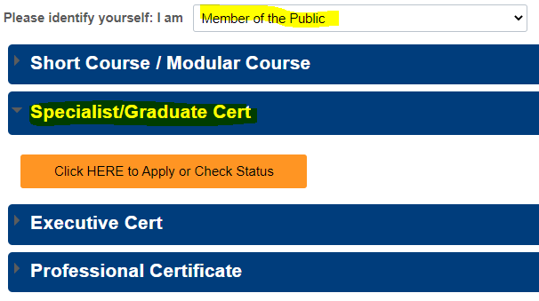

**Step 4: Submit an Application for Module**

1. Click on “Submit a New Application”

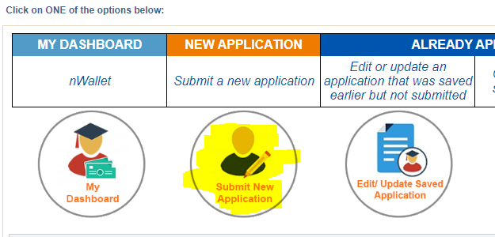

2. Choose the following in the dropdown menu • Academic Year & Semester : “2024/2025 Semester 1”

• Programme/Student Category: “GDCert-Health Econ Eval”

• Specialisation /Level of study : “Health Economic Evaluation”

3. Click on “Apply Now”

4. Click on “Add/Select New Module”

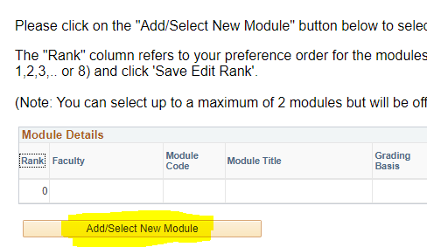

5. Under Faculty, choose “Duke-NUS Medical School”

6. Under Module Code, type in “GMS5223” for course “Advanced Health Econometrics” or “GMS5224” for course “Advanced Health Technology Assessment Methods”

7. Search for the module

8. Check the box under the column “Select”

9. Click on “Save” to add the module

10. You will see the module added in the main application page.

11. Click on “Save & Proceed to Next Page”

**Step 5: Complete personal particulars.**

1. **Personal Particulars** - Retrieve your personal particulars using Singpass. Otherwise, you will need to upload a copy of your IC manually later on

2. **Academic Qualification** - Add only your Highest Academic Qualification by clicking on “Add New Qualification”

3. **Employment Details** – Add your current employment details

4. **Upload supporting documents** – Upload all necessary documents. You do not need to upload your IC if you retrieved your info using Singpass

5. **Other Details & Declaration** - Submit as per on screen instructions

6. **Confirmation** – Check and ensure all details that you have submitted are accurate

**Step 6: Save your Application Number.**

1. After submission, write down the Application number which begins with N0000xxxx (See image below)

2. You will need the application number in Part III:Matriculation



**Step 7: Inform us that you have completed this step**

1. Please email Jason ([Jason@nus.edu.sg](mailto:Jason@nus.edu.sg)) that you have completed your application so that he can proceed to make you an offer